# Workshop gamification (approx. 2 hours)

Gamification is the craft of deriving all the fun and engaging elements found in games and applying them to real-world or productive activities. This process is what I call “Human-Focused Design,” as opposed to “Function-Focused Design.” It’s a design process that optimizes for human motivation in a system, as opposed to pure efficiency.

– Yu-Kai Chou –



*A chinook salmon attempts to return to her birth ground to lay her eggs*

**Assignment**

*Read Octalysis – gamification framework* (Level 1)

<http://yukaichou.com/gamification-examples/octalysis-complete-gamification-framework/#more-2275>

Gamification places emphasis on human motivation. It is Human focused rather that Function focused.

**Chou identifies 8 core drives of gamification:**

|  |  |
| --- | --- |
| *1. Epic meaning & calling*  *2. Development & accomplishment*  *3. Empowerment of creativity & feedback*  *4. Ownership & possession* | *5. Social influence & relatedness*  *6. Scarcity & impatience*  *7. Unpredictability & curiosity*  *8. Loss & avoidance* |

|  |  |  |
| --- | --- | --- |
|  | *Positive Motivations* |  |
| *Extrinsic Motivation* | /Users/arjang2/Desktop/Schermafbeelding 2017-08-21 om 10.57.18.png | *Intrinsic Motivation* |
|  | *Negative motivations* |  |
|  | | |

Not all core drives need to be present.

Next: some examples

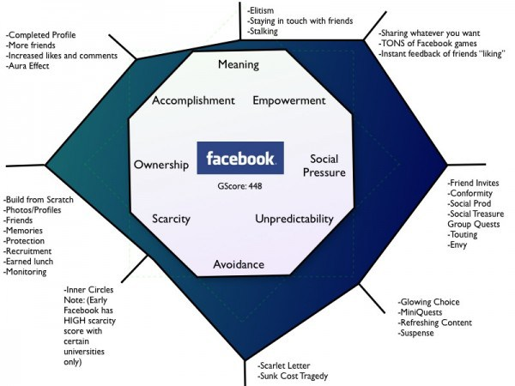

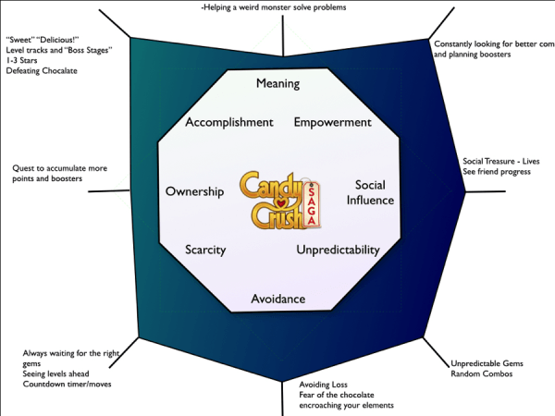

**Assignment**

Now, think of a/your project and create an Octalysis schematic emphasizing the core drives of your concept.

* What is the focus? Left or right brain?
* Which core drives have strong presence?
* To which features of your concept do the core drives relate?
* Which are lacking or could easily be added? Why?

**Assignment**

Visit <http://www.yukaichou.com/octalysis-tool/> and create your graph. Add screenshot to workshop assignment.

